ISSN 1847-7917

Template for the article in MTSM 2020

AuthorName AUTHORSURNAME¹⁾, Name2 SURNAME2²⁾ and Name3 SURNAME3¹⁾
1) Authors' affiliation 1
Full affiliated institution address, Country1
2) Authors' affiliation 2
Full affiliated institution address, Country2
authors_e-mail@address.url

Keywords
KeywordA
KeywordB
KeywordC
KeywordD
KeywordE

Type of paper
Abstract: The following template contains examples of paragraph styles and formatting. While browsing the template, the styles change in the Style pane options. Use the text in this template as a guideline on which style to select for specific text categories (Authors' names, keywords etc.). The guidelines and examples provided in this document can sometimes be modified to suit specific layouts. When deviating from the template, one should regard the article conformity in regard to the overall journal layout. Some layout changes could occur, compared to the submitted manuscript, when the final typeset is done.

Introduction to the Article Layout
This template is intended for clarification of issues regarding the layout and formatting of articles submitted for publication. The total number of pages in the article should be an even number, avoid blank pages. The article should be formatted in two columns, both equal column width of 8 cm with a spacing of 5 mm. There is no style that incorporates column formatting so this part should be done by the author (section breaks where necessary).
Paragraph text should be formatted with the Normal style (Times New Roman, 10pt) There is no first line tab or other decorative paragraph formatting. The Font Times New Roman should be used, as well for all other text (including text appearing in Figures). The title of the article is formatted with STR_ArticleTtitle style. Section headings are formatted hierarchically with styles Heading 1 and Heading 2 and are numbered automatically.
After the first page, which contains the abstract and introduction, the top part of the second page should contain the table of symbols, Greek letters and subscripts, each in their alphabetical order, that are used in the article. Variables should be written in Italics, while subscripts and matrix designations should not. Matrices (J = [0]) should also be bold. Measurement units, where applicable, should follow the principal article language, separated by a comma.
The introduction should, if necessary, continue after the table of symbols.
The usage of the decimal comma (e.g. 1,2) is requested throughout the text, formulae, tables, and figures. However, articles written in English can use the decimal point (e.g. 1.2) if this is kept consistent throughout the article text, formulae, tables, and figures.

Symbols

e_{hyd} | - specific hydraulic energy, m²s⁻² | μ | - dynamic viscosity, Pa s
g | - acceleration due to gravity, ms⁻² | ρ | - density, kgm⁻³
H_{loss} | - hydraulic losses, m | φ | - general characteristic
H_{st} | - static head, m | ω | - angular velocity, rad s⁻¹
HKSM | - wicket gate servomotor position, %
k | - turbulent kinetic energy, m²s⁻² |  | Subscripts
k_{p} | - pipeline constant, , m⁵s² | ₁ | - high pressure reference section
 |  | ₂ | - low pressure reference section
 | Greek letters | _{HW} | - headwater
ε | - turbulent dissipation rate, m²s³ | _{TW} | - tailwater
η | - turbine hydraulic efficiency, % | _{t} | - turbulent

Tables and table captions

Formatting large tables
As shown below in Table 1, if the table spans the width of the document, it should be centered and its width set to fit inside the inner and outer margins. The text inside the table is formatted with Table Grid style by default. Other formatting of table text can be applied at authors' discretion, maintaining legibility. After this kind of table layout one empty paragraph should be inserted for spacing purposes.

Table 1. Example of the table spread over the width of the document: Chapter Heading font sizes
Formatting Style | Heading 1 | Heading 2 | Table Grid | Abstract
Font size, pt | 12 | 10 | 9 | 9

Formatting small tables
Small tables (like Table 2) should be sized to fit the width of a single column. If this is not possible, the table and corresponding table caption should be put in a separate section without column formatting (as a large table). Captions above the tables are not numbered automatically. This applies for caption below figures as well as for equations. Any item that should be numbered must be numbered manually by the author.

Table 2. Example of placing small table in a column-formatted text
Margin | Top | Bottom | Inner | Outer
Value | 1.7 | 1.7 | 2 | 2

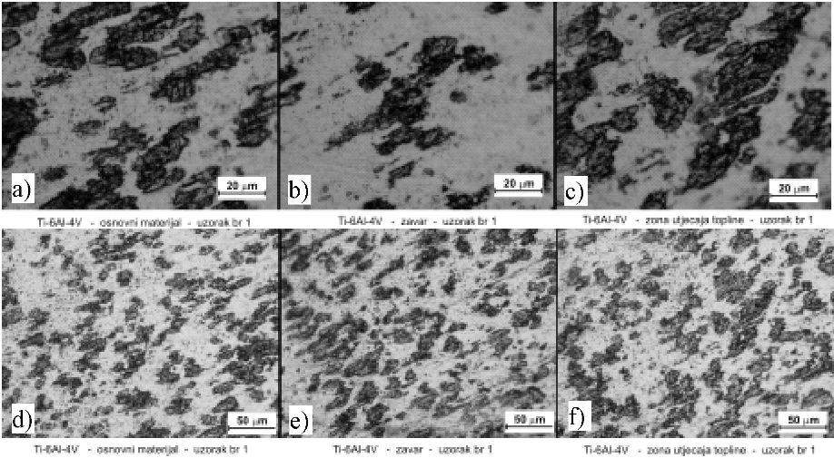
Figure 1. Metallographic photos of alloy Ti-6Al-4V (two different magnifications) – base material –weld-heat affected zone Etching: Kroll reagens 100 ml water, 2 ml HF, 5 ml HNO₃

Figures, captions and wrapping

Large figures and figure captions
As well as wide tables, large figures (Figure 1) should be centered along the width of the document. The figure (or the line containing it) should be formatted with the style STR_Figure. Figure caption should be placed below the figure and formatted with the style STR_Caption below picture making it left aligned. The word Figure, its number and the full stop should be bolded. In order to avoid potential problems regarding typeset, text frames or object groups should not be used within the figure, only raster images.
Figures formatted with STR_Figure style will be properly spaced before and after so there is no need for extra frame of white borders inside the actual figure. If the caption below the figure overlaps a single line it will be wrapped. Multi-line captions should begin with a tab between the figure number point and the start of figure caption text.
Special formatting (in MS-Word) can be entered through simultaneous pressing of key combinations. Manual line wrapping breaks can be inserted by pressing the key combination SHIFT+Enter. Non-breaking spaces (e.g. 180 m) and non-breaking hyphens (e.g. case-sensitive) are obtained using the key combinations Ctrl+SHIFT+Space and Ctrl+SHIFT+- respectively. Displaying print characters (Standard Toolbar button ¶ ) can help during layout adjustments.

Formatting small figures
Small figures like Figure 2 should be sized to fit the width of a single column (or less, centered). Figures should be greyscale or B/W raster images with a preferred resolution of at least 300 dpi. The text occurring in figures properly sized for the final layout should also not be larger than 10pt, Times New Roman, and it should also follow the bilingual guidelines set for table contents (principal article language/translated). Using embedded graphical objects as well as editable vector graphics should be avoided because of compatibility issues (including WordArt).
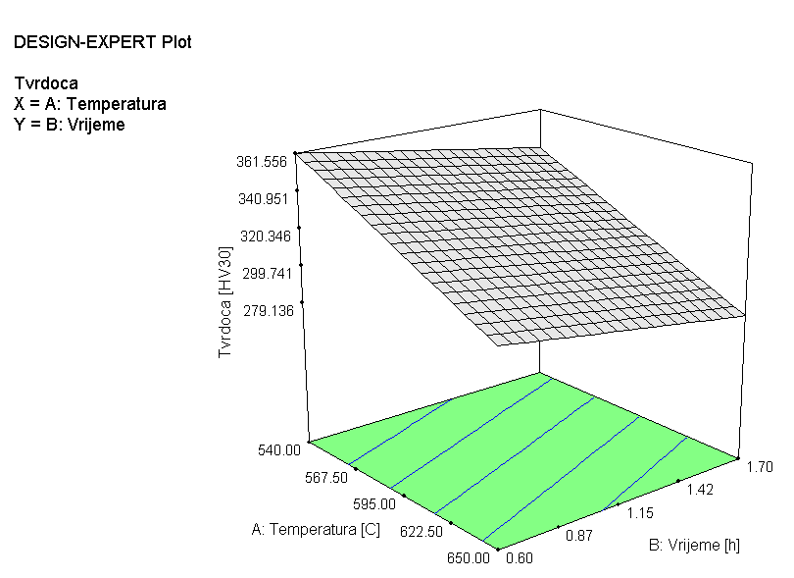
Figure 2. 3D diagram of mathematical model

Equations and lists

Equations
Equations should be written using the MS word integrated MS Equation editor. For compatibility issues the most common fonts should be used (MS Equation editor menu command: Styles > Define). General text and numbers should be written by using regular font Times New Roman or similar. Variables, counting indexes and letters representing physical values should be written with the same font but in italics. The font Symbol in italics, or similar should be used for Greek letters.
Basic equation text height should be set to 10 pt while heights of other elements are given in the form of percentages. Equations should be sized as shown on figure 3 (MS Equation editor menu: Sizes > Define).
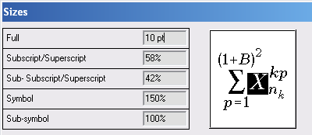
Figure 3. Equation font sizes
Equations should be aligned to the left margin or, if necessary, centered across the width of a single column by using style STR_Equation. In both cases there are two tab stops: one center tab stop regarding column width and one right-aligned tab stop at the column margin, the latter provided for equation numbering purposes. Equations should be numbered as in the example below, regarding their first appearance in the whole article. Numbers should be placed after the tab without extraneous spaces. Lists of equations should have interpunction, each separated by a comma and the last one ending with a full stop as follows:
, (1)
. (2)
For large equations that do not fit in the column width there is a similar style, STR_EquationL. It can be used as the previous one but its tab stops are formatted regarding page width instead of a single column. This kind of equations should likewise be excluded from column formatting.

Lists
Lists should be formatted with the style STR_List_1.
- Preceding character is a long dash,
- It is slightly indented as to differ from the text body using commas to separate list items and a full stop after the last item.

References
Cited references [1] in the article text should consist of the publication's reference number [2] in brackets separated with a comma when citing two or more (e. g. [3], [4] and [5]) consecutive references.
The list of references should appear at the end of the article under the title REFERENCES. Listed references should be numbered according to the order of their first appearance in the article text. The formatting style used is STR References and the various types of reference sources should be formatted with titles in italics according to the examples listed here.

Acknowledgements
Acknowledgements, if any, should appear before the references.
References
- ASM Handbook, (1991), Vol 4- Heat Treating, ASM International, Metals Park, OH, USA,

- Deželić R., (1987), Metali 2, Sveučilište u Splitu, FESB, Split

- Prabal R., Ratan G., Ashok P., (2002), Influence of Heat Treatment Parameters on Structure and Mechanical Properties of an HSLA-100 Steel, Steel Research 73 No. 8, p 347-355 Germany

- Stanić J., (1986), Metod inžinjerskih mjerenja, Mašinski fakultet, Beograd

- STAT EASE, Inc.: DESIGN – EXPERT v.6.0.10, Minneapolis, MN 55413

- Totten G. E., (2006), Steel Heat Treatment – Metallurgy and Technologies, Portland State University, Portland, Oregon, U.S.A

- Živković D., Gabrić I., Šitić S., (2012), Analysis of heat treatment influence on the hardness of steel EN 42CrMo4, MATRIB 2012, Vela Luka, Korčula

