Template for the article in MTSM 2024

Author Name Surname¹, Name Surname² and Name Surname¹

1) Authors' affiliation 1, Full affiliated institution address, Country1
2) Authors' affiliation 2, Full affiliated institution address, Country2
Corresponding author: e-mail@address.url

Type of paper
Abstract: The following template contains examples of paragraph styles and formatting. While browsing the template, use the text in this template as a guideline on which style to select for specific text categories (Authors' names, keywords etc.). The guidelines and examples provided in this document can sometimes be modified to suit specific layouts. When deviating from the template, one should regard the article conformity regarding the overall proceeding’s layout. Some layout changes could occur, compared to the submitted manuscript, when the final typeset is done.

Keywords: keyword A; keyword B; keyword C; keyword D; keyword E
- Introduction to the Article Layout
This template is intended for clarification of issues regarding the layout and formatting of articles submitted for publication. The total number of pages in the article should be an even number, avoid blank pages.
Paragraph text should be formatted with the Normal style (Calibri, 11pt). The text should be written in Microsoft Word .docx format file. There is no first line tab or other decorative paragraph formatting. The Font Calibri should be used, as well for all other text (including text appearing in Figures). Section headings are formatted hierarchically and numbered automatically. Variables should be written in Italics, while subscripts and matrix designations should not. Matrices (J = [0]) should also be bold. The usage of the decimal point (e.g. 1.2) is requested throughout the text, formulae, tables, and figures.

Tables and table captions
The text inside the table is formatted with Table Grid style by default. Other formatting of table text can be applied at authors' discretion, maintaining legibility. After this kind of table layout, one empty paragraph should be inserted for spacing purposes. An example of the table format is shown below. The word Table, its number and the full stop should be bolded.

Table 1. Example of the table spread over the width of the document
Formatting Style | Heading 1 | Heading 2 | Table | Figure and table caption
Font size, pt | 12 | 11 | 11 | 10

Figures, captions and wrapping

Large figures and figure captions
Figures such as Figure 1 should be cantered along the width of the document. Figure caption should be placed below the figure and centred. The word Figure, its number and the full stop should be bolded. In order to avoid potential problems regarding typeset, text frames or object groups should not be used within the figure, only raster images.

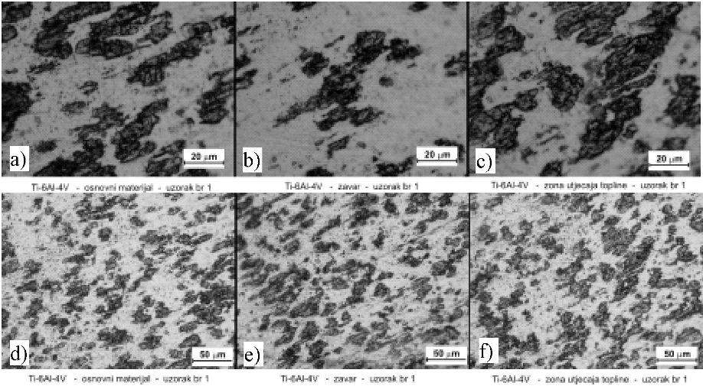
Figure 1. Metallographic photos of alloy Ti-6Al-4V (two different magnifications) – base material –weld-heat affected zone Etching: Kroll reagent 100 ml water, 2 ml HF, 5 ml HNO3

Equations and lists

Equations
Equations should be written using the MS Word integrated MS Equation editor. General text and numbers should be written using regular font Times New Roman or similar. Variables, counting indexes and letters representing physical values should be written in the same font but in italics. The font Symbol in italics, or similar should be used for Greek letters. Basic equation text height should be set to 11 pt while heights of other elements are given in the form of percentages. An example of the equation is as follows:

 | $$W=\int_{0}^{ε_{50\% }}{σ\left(ε\right)dε}$$ | (1)

Lists
Equations should be centered across the width of a single page. Equations should be numbered as in the example below, regarding their first appearance in the whole article. Numbers should be aligned right as in the example below.

 | $$z_{CPE}={[Q{\left(jω\right)}^{n}]}^{-1}$$ | (2)

 | $$R_{P}=\lim_{ω⟶0}{[Z_{real}]}$$ | (3)

References
Cited references [1] in the article text should consist of the publication's reference number [2] in brackets separated with a comma when citing two or more (e. g. [3], [4] and [5]) consecutive references.
The list of references should appear at the end of the article under the title References. Listed references should be numbered according to the order of their first appearance in the article text. The formatting style should be as in the example references section.

Acknowledgments
Acknowledgments, if any, should appear before the references.

References
Reference to a book:
[1] Deželić, R., 1987. Metali 2, Sveučilište u Splitu, FESB, Split
Reference to a journal publication:
[2] Van der Geer, J., Hanraads, J.A.J., Lupton, R.A., 2010. The art of writing a scientific article. J. Sci. Commun. 163, 51–59.
Reference to a conference:
[3] Živković, D., Gabrić, I., Šitić, S., 2012. Analysis of heat treatment influence on the hardness of steel EN 42CrMo4, MATRIB 2012, Vela Luka, Korčula
Reference to a website:
[4] Metals Research, UK, 1975. Statistics reports for the UK. http://www.metalresearchuk.org/aboutmetal/statistics/metalstatsreport/ (accessed 13 March 2022).
Reference to software:
[5] Coon, E., Berndt, M., Jan, A., Svyatsky, D., Atchley, A., Kikinzon, E., Harp, D., Manzini, G., Shelef, E., Lipnikov, K., Garimella, R., Xu, C., Moulton, D., Karra, S., Painter, S., Jafarov, E., & Molins, S., 2020. Advanced Terrestrial Simulator (ATS) v0.88 (Version 0.88). Zenodo.

